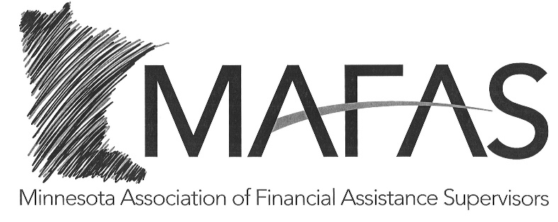

**2024 MAFAS MEMBERSHIP**

**Cost: $45.00**

If you wish to become or continue as a member of MAFAS in 2024, please complete the following information and return this form with your payment.

Name:

Agency:

Address:

Email address:

Telephone:

**Make membership check payable to MAFAS—if paying with one check for multiple Supervisors please put their names on the check invoice line.**

Please return the completed form and membership check to the address listed below. **ACH available, please reach out for details

Naomi Morris-MAFAS Treasurer [Naomi.Morris@OlmstedCounty.gov](mailto:Naomi.Morris@OlmstedCounty.gov)

Olmsted County Program Manager (507) 328-7933

608 16th Street South

La Crosse, WI 54601