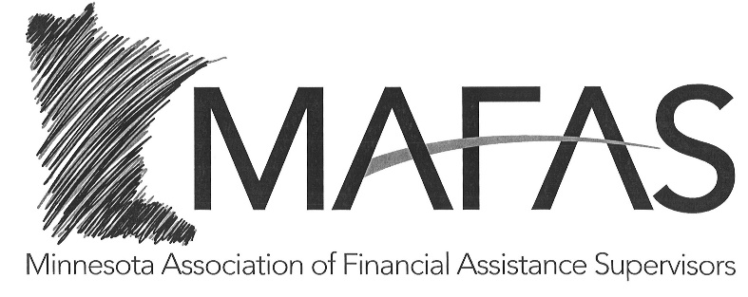

2026 MAFAS MEMBERSHIP
Cost: $45.00

If you wish to become or continue as a member of MAFAS in 2026, please complete the following information and return this form with your payment.

Name:

Agency:

Address:

Email address:

Telephone:

Make membership check payable to MAFAS—if paying with one check for multiple Supervisors please put their names on the check invoice line.

Please return the completed form and membership check to the address below. **ACH available, please reach out for details

Naomi Morris-MAFAS Treasurer Naomi.Morris@OlmstedCounty.gov
Olmsted County Program Manager (507) 328-7933
608 16th Street South
La Crosse, WI 54601

